Name _________________

Extra Credit - GEOL 3305 Fronts
Due November 22

Go to my web page and click on the "U. S. Weather Map" link. Sketch the fronts and show Lows and Highs for each of four days.
All you want are the Lows, Highs, the fronts.

(cold fronts have the blue triangles 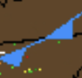 warm fronts have the little red half circles 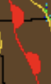
The lows are a big red L and the highs are a big blue H.

Remember to use the barbs (or triangles) on the cold fronts and the little half circles on warm fronts.
The time of the chart is in Zulu time (GMT) It will be a number followed by “Z”. (e.g. 0900Z)

Date _________ Time ______________ Source ________
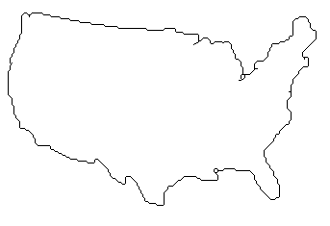

Date _________ Time ______________ Source ________
Date _________ Time ______________ Source ________

Date _________ Time ______________ Source ________

